LAB 1 - Get data
Duration - 30 minutes
____________________________________________________________________________

Cloud Lab – Participant Access Instructions

Please follow the steps below to access your assigned VM and begin the lab exercises.

Open the Cloud Lab Portal

Open the following URL in your browser:
Cloud Lab Portal (https://cloud.cdp.rpsconsulting.in/console/#/ )

Sign In

Use the credentials provided to you:
Details | Information
Username | Your assigned username (e.g., 27SAC0722_U01)
Password | We!C0me@21
Admin | We!C0me@21

Important: Use the username assigned specifically to you. Do not use another participant's credentials.

Verify the Lab Environment
Before starting the exercises, verify that you can access the Windows desktop and required applications are available, such as:

Required lab files and datasets ( Download Lab Files)

Power BI Desktop

SQL Server / SQL Server Management Studio (SSMS)

Internet/browser access
___________________________________________________________________________

Get started with Power BI Desktop
To complete this exercise, first open the folder and download the 01-get-data folder.
Open the 01-Starter-Sales Analysis.pbix file.This starter file has been specially configured to help you complete the lab.

Get data from SQL Server
This task teaches you how to connect to a SQL Server database and import tables, which create queries in Power Query.
- On the Home ribbon tab, from inside the Data group, select SQL Server.
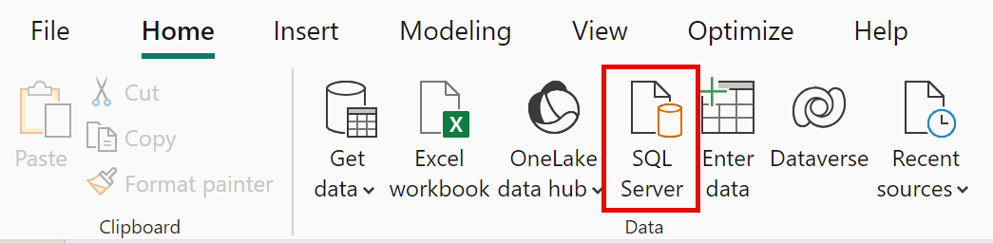
- In the SQL Server Database window, in the Server box, enter localhost and leave Database blank, then select OK.
Note: In this lab, you’ll connect to the SQL Server database by using localhost. While this is fine for the lab, it’s not considered a best practice for real-world solutions.
- If prompted for credentials, select Windows > Use my current credentials, and then Connect.
- Select OK if you receive a warning that an encrypted connection cannot be established.
- In the Navigator pane, expand the AdventureWorksDW2020 database.
Note: The AdventureWorksDW2020 database is based on the AdventureWorksDW2017 sample database. It has been modified to support the learning objectives of the course labs.
- Select the DimEmployee table, and notice the preview of the table data.
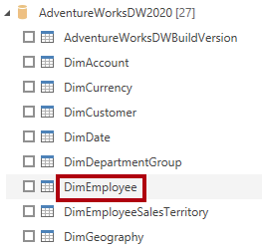
Note: The preview data allows you to see the columns and a sample of rows.
- Select the following tables by checking the boxes next to their names.
  - DimEmployee
  - DimEmployeeSalesTerritory
  - DimProduct
  - DimReseller
  - DimSalesTerritory
  - FactResellerSales
- Complete this task by selecting Transform Data, which will open Power Query Editor - leave this open for the next task.
You've now connected to six tables from a SQL Server database.

Preview Data in Power Query Editor
This task introduces the Power Query Editor and allows you to review and profile the data. This helps you determine how to clean and transform the data later.
You'll also review both dimension tables prefixed with "Dim" and fact tables prefixed with "Fact".
- In the Power Query Editor window, at the left, notice the Queries pane. The Queries pane contains one query for each table you checked.
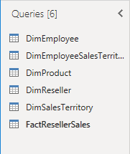
- Select the DimEmployee query.
The DimEmployee table in the SQL Server database stores one row for each employee. A subset of the rows from this table represents the salespeople, which will be relevant to the model you’ll develop.
- At the bottom left corner of the status bar, some table statistics are provided—the table has 33 columns, and 296 rows.
- In the data preview pane, scroll horizontally to review all columns. Notice that the last five columns contain Table or Value links.
These five columns represent relationships to other tables in the database. They can be used to join tables together. You’ll join these tables later in the Load Transformed Data in Power BI Desktop lab.
- To assess column quality, on the View ribbon tab, from inside the Data Preview group, check Column Quality. The column quality feature allows you to easily determine the percentage of valid, error, or empty values found in columns.
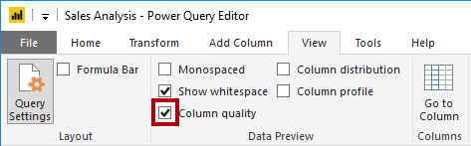
- Notice that the Position column has 94% empty (null) rows.
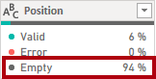
- To assess column distribution, on the View ribbon tab, from inside the Data Preview group, check Column Distribution.
- Review the Position column again, and notice that there are four distinct values, and one unique value.
- Review the column distribution for the EmployeeKey column—there are 296 distinct values, and 296 unique values.
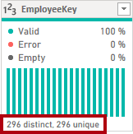
Note: When the distinct and unique counts are the same, it means the column contains unique values. When modeling, it’s important that some model tables have unique columns. These unique columns can be used to create one-to-many relationships, which you'll do in the Model Data in Power BI Desktop lab.
- In the Queries pane, select the DimProduct query.
The DimProduct table contains one row per product sold by the company.
- In the Queries pane, select the DimReseller query.
The DimReseller table contains one row per reseller. Resellers sell, distribute, or value add to the Adventure Works products.
- To view column values, on the View ribbon tab, from inside the Data Preview group, check Column Profile.
- Select the BusinessType column header, and notice the new pane beneath the data preview pane. Review the column statistics and value distribution in the data preview pane.
Notice the data quality issue: there are two labels for warehouse (Warehouse, and the misspelled Ware House).
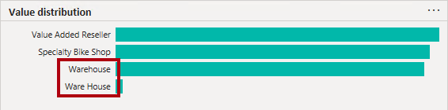
- Hover the cursor over the Ware House bar, and notice that there are five rows with this value.
- In the Queries pane, select the DimSalesTerritory query.
The DimSalesTerritory table contains one row per sales region, including Corporate HQ (headquarters). Regions are assigned to a country, and countries are assigned to groups. In the Model Data in Power BI Desktop lab, you’ll create a hierarchy to support analysis at region, country, or group level.
- In the Queries pane, select the FactResellerSales query.
The FactResellerSales table contains one row per sales order line—a sales order contains one or more line items.
- Review the column quality for the TotalProductCost column, and notice that 8% of the rows are empty.
Missing TotalProductCost column values is a data quality issue.

Get data from a CSV file
In this task, you'll create a new query based on CSV files.
- To add a new query, in the Power Query Editor window, on the Home ribbon tab, from inside the New Query group, select the New Source down-arrow, and then select Text/CSV.
- Navigate to the Downloads > 01-get-data folder you extracted earlier and select the ResellerSalesTargets.csv file. Select Open.
- In the ResellerSalesTargets.csv window, review the preview data. Select OK.
- In the Queries pane, notice the addition of the ResellerSalesTargets query.
The ResellerSalesTargets CSV file contains one row per salesperson, per year. Each row records 12 monthly sales targets (expressed in thousands). The business year for the Adventure Works company commences on July 1.
- Notice that no column contains empty values. If a monthly sales target is missing, the column shows a hyphen instead.
- Review the icons in each column header, to the left of the column name. The icons represent the column data type. 123 is whole number, and ABC is text.
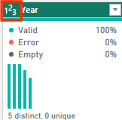
- Repeat the steps to create a query based on the ColorFormats.csv file.
The ColorFormats CSV file contains one row per product color. Each row records the HEX codes to format background and font colors.
You should now have two new queries, ResellerSalesTargets and ColorFormats.
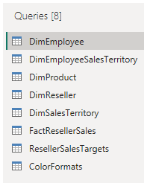

Lab complete
You may choose to save your Power BI report, though it’s not necessary for this lab. In the next exercise, you’ll work with a pre-made starter file.
- Navigate to the "File" menu in the top left corner and select "Save As".
- Select Browse this device.
- Select the folder where you want to save the file and give it a descriptive name.
- Select the Save button to save your report as a .pbix file.
- If a dialog box appears prompting you to apply pending query changes, select Apply.
- Close Power BI Desktop.

